**Engkanto**

**Team Hiraya**

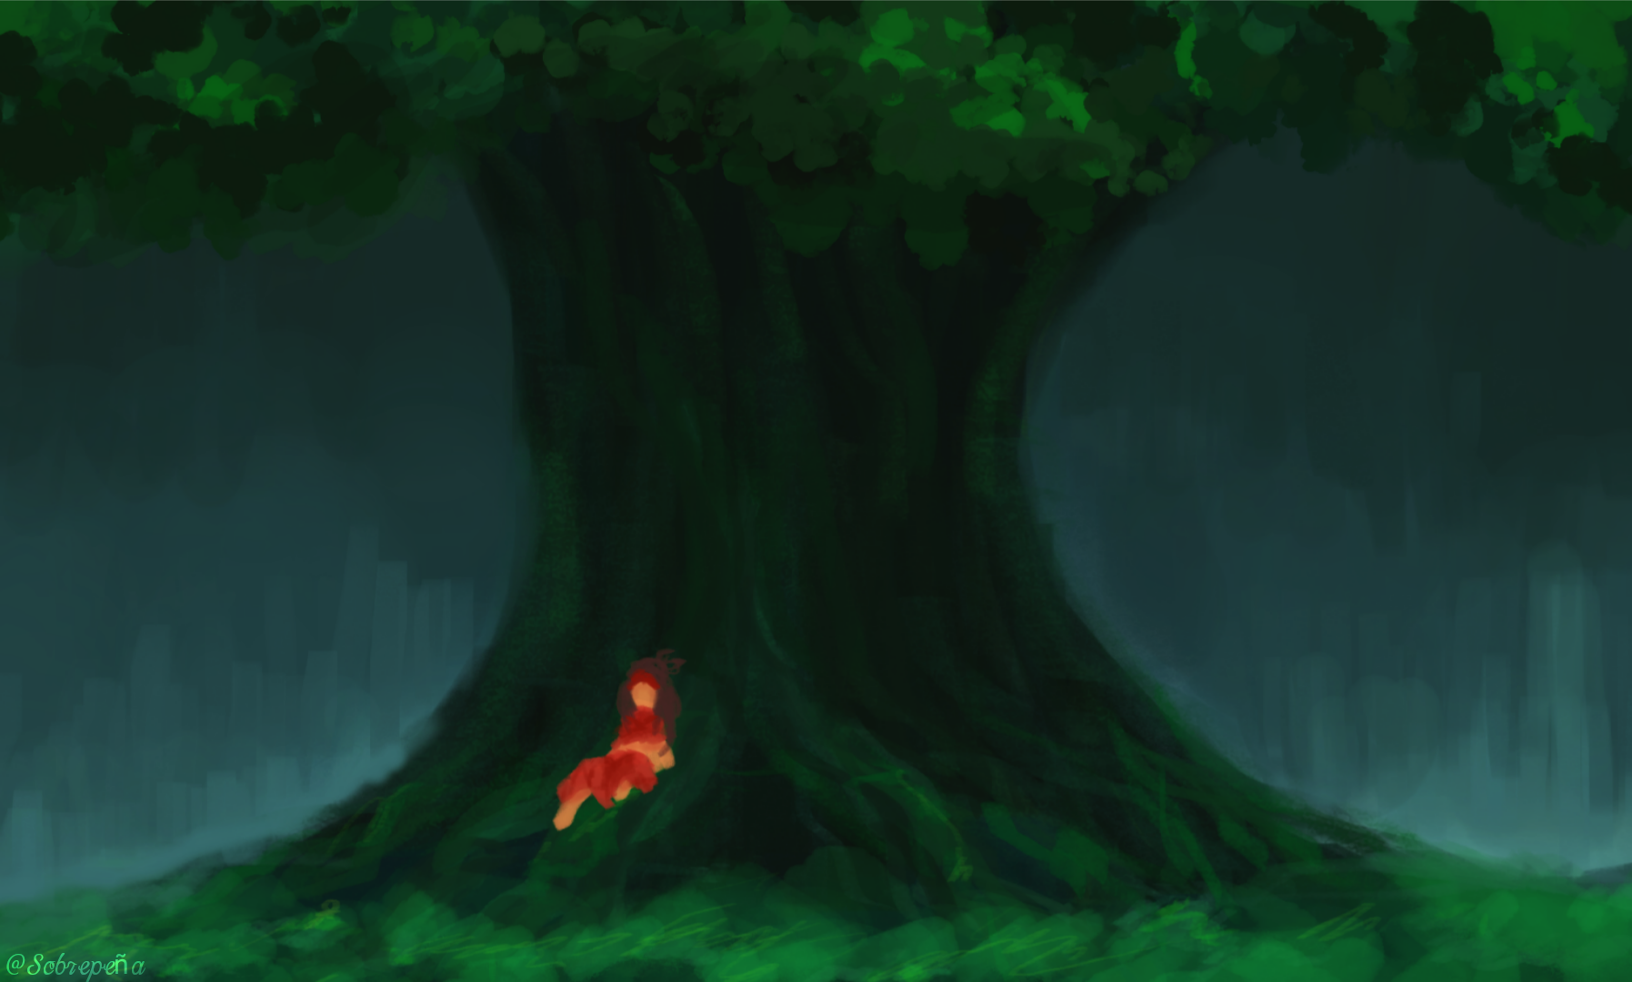

We are a small indie team driven by imagination and purpose — creating games, animation, art, and more. Rooted in the meaning of **Hiraya** — "the fruit of one's hopes and dreams" — our work reflects a balance of vision, discipline, and respect. This is where creativity grows, ideas take shape, and dreams find their form.

## Team Vision

At Team Hiraya, we believe in creating experiences that resonate — but as stories told through interaction. Artistry, and heart. Engkanto is our love letter to Filipino mythology, to the explorers who cherish deep worlds, and to every dreamer who believes in the magic of a well-told tale.

*Thank you for visiting our world*

*-Sobrepeña*

# **Introduction**

Engkanto is a 2D action adventure game inspired by Team Cherry Hollow knight and Hollow knight: Silksong, reimagined through filipino setting, Set in a dark, mysterious world filled with creatures from Philippine mythology, the game blends exploration, combat, and storytelling into a deeply atmospheric experience.

You play as Raya, a young girl who mysteriously wakes up in an unfamiliar world teeming with spirits, gods, monsters. Armed only with her arnis, Raya must journey across diverse regions, uncover the secrets of the land, and find a way back to the real world.

Throughout her adventure, Raya encounters various characters who speak in different Filipino dialects, each offering fragments of lore, guidance, and challenges that deepen the world's mystery. The game emphasizes exploration, fast paced combat, and emotional storytelling, inviting players to uncover the truth behind Laurel's presence in this strange land and the hidden history of the Engkanto word itself.

# **Inspirations**

* Shantae and the seven sirens
* Hollow Knight
* Hollow Knight:Silksong
* Raman Legends
* Ori and the Blind Forest

# **Platforms**

* Mobile
* Web
* Pc

# **Software**

* Visual Studio Code
* Kirita
* Clip Studio Paint
* Adobe Flash CS6
* Spine 2D
* ShoeBox

# **Genre**

* Metroid Vania
* Platformer
* Single Player
* Adventure
* Puzzle
* Emotional
* Indie
* Fantasy
* Open World

Ⅰ. The Golden Cage

## Characters

### **Hiraya - (The Spirit of Hope)**

Hiraya is a radiant, spectral spirit who appears to Raya as a guide. She claims to be the Diwata ng Pag-asa, the Golden Heart of Engkanto, who was imprisoned long ago by a jealous force. Trapped in an amber chrysalis deep beneath the earth, she can only communicate through visions and whispers. Her voice is a melody of warmth and comfort, promising Raya that if she can brave the decaying ruins and break the ancient seals, Hiraya will rise to restore the land to a paradise of eternal sunlight and end all suffering. To a lost girl in a dark world, she is a beacon of purpose and a promise of salvation.

References:

[English young Rapunzel Healing Song](https://youtu.be/mKS8dbg8cM0?si=E12eWG-BVN3oW1IS)

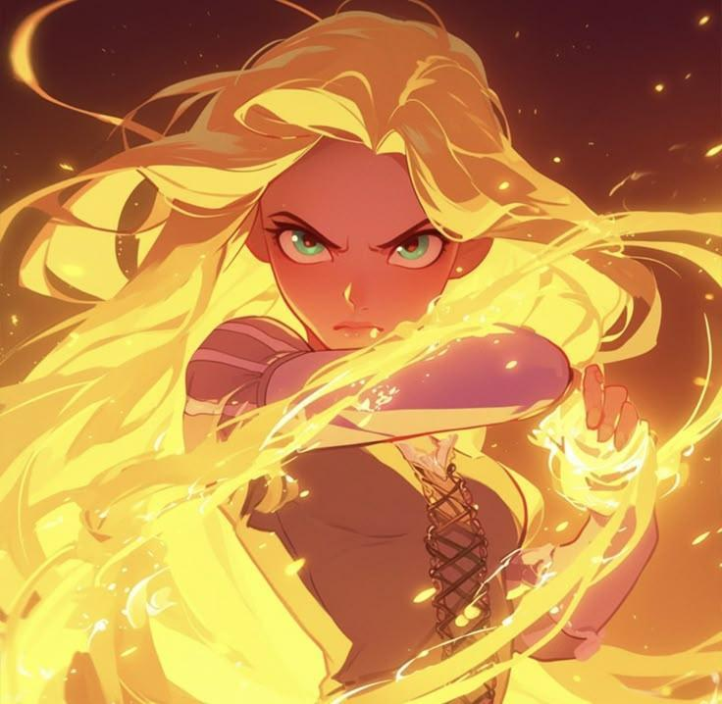

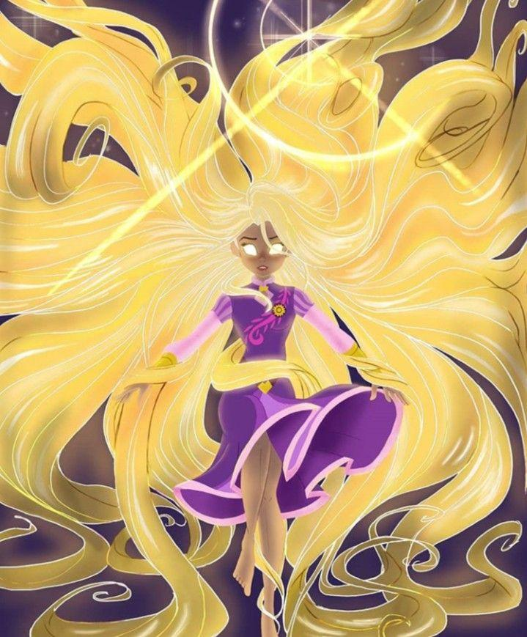

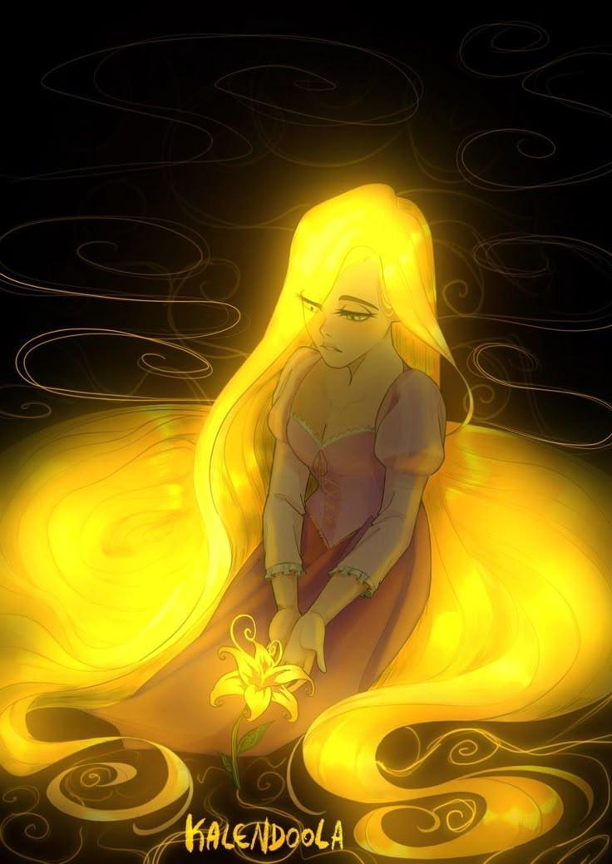

### **Himlay - (The Spirit of Despair)**

Himlay is a feared and sorrowful witch who drifts through Engkanto like a living curse. A spectre woven from black roots, dried vines, and gray fog, she is the silent warden of the seals Raya is tricked into breaking. Where Himlay passes, life is not merely destroyed—it is honestly revealed: stone crumbles to show its age, and flowers wilt to return to the soil. She conjures walls of thorns and spectral guardians not only to obstruct Raya, but to test her resolve. Her whispers are not temptations toward emptiness, but eerie warnings against blind faith: *"What grows without a shadow?"* and *"Do not mistake a gilded cage for the sky."* She is the world's painful truth, mistaken for its villain.

References:

[Rapunzel - Wither and decay](https://youtu.be/_jZ6LTmyW6U?si=PLCH64uE1fT0qewo)

[Wither and decay 2.0](https://youtu.be/T7dCyLFYm9w?si=aRb7Zi1Utp9QbfTc)



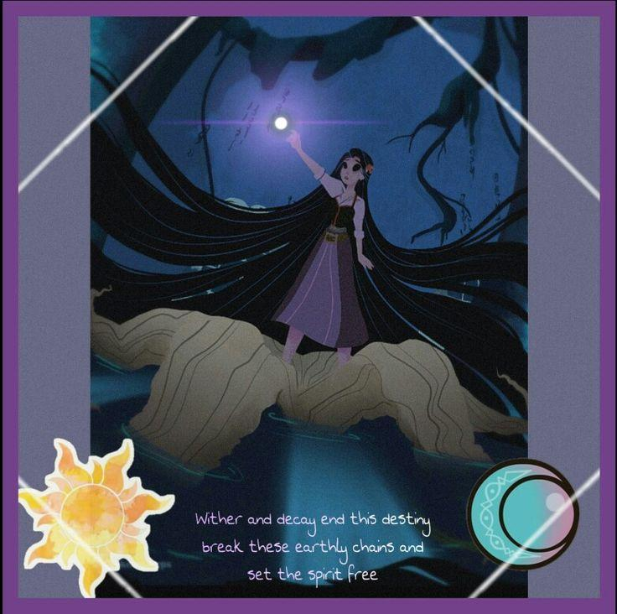

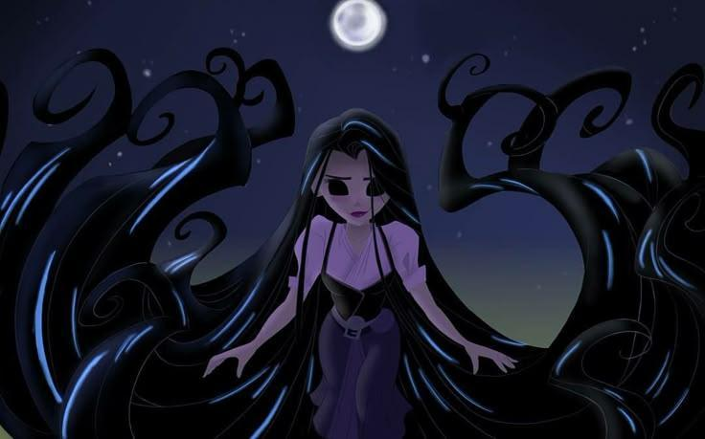

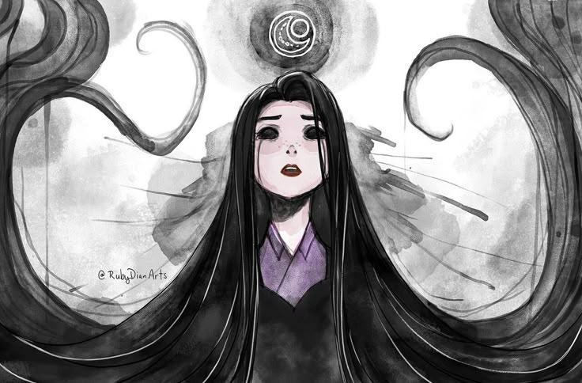

**Raya - (The lost Child)** A Filipino girl in her mid-teens, with sharp, observant eyes that hold both determination and deep-seated worry. Her hair is tied back practically, and she wears a modern, simplified version of traditional clothing, a durable *baro't saya* now stained with dirt and moss from Engkanto. She moves with the focused grace of someone trained in Arnis, her movements economical and precise even in panic.

Raya Backstory in the real world:

Raya was raised in a tight-knit community by her lola(grandmother), a practicing albularyo (Folk Healer) who kept the old stories alive. Her lola’s house was a place of dried herbs, whispered oraciones (prayers), and warnings about respecting the unseen world. Raya learned the dances, the stories

# **Project Structure**

If you made your own package/function add your name in the curly brackets, unless if it is a built in function make sure it is specified

**You can check out the cheat sheet from the Haxeflixel website:**  
<https://haxeflixel.com/documentation/cheat-sheet/>

# **Source Folder (Base)**

## Main.hx (Entry Point Class)

The main class is the entry point of the game. It sets up the game window and tells HaxeFlixel which state to start with. Keep in mind that state is like a scene in the game.

### new() [function] :

Constructor that runs once when the game starts

### FlxGame() [Object Class] :

It is the heart of all Flixel games, and contains a bunch of basic game loops and things. It is a long and sloppy file you shouldn’t have to worry about too much! It is basically only used to create your game objects in the first place, after that FlxG and FlxState have all the useful stuff you actually need.

## PlayState.hx (Entry Point Class)

The play state is where the actual game happens.

**This is where you:**

* Create players, enemies, backgrounds
* Handle input
* Update logic
* Detect collisions

Think of a state as a scene or screen (like levels, menus, etc.)

### create() [function] :

Runs ONCE when the state starts.

**Used for:**

* Creating sprites
* Loading backgrounds
* Setting up UI
* Initializing variables

### update(elapsed:Float) [function] :

Runs EVERY FRAME.

**Used for:**

* Movement
* Input Checks
* Physics
* Collision handling

# **States (x40 Package)**

This Package contains all of the scenes, for example Main Menu, Settings, UI and more.

## MenuState.hx (x40 Class)

This class is the main menu, it contains objects from different classes inside the States Package.

This class extends the FlxState Class:

Check the website for more info, if you notice we override the methods since FlxState class has the same function, keep in mind that each extends of a class has different structures

**Check out the website for the FlxState class for more info:**

<https://haxeflixel.com/documentation/flxstate/>

### create() [Override function] :

This is where you set up and create all your state's objects; for example your level tilemaps, your player sprites, and spawn your initial enemies. Flixel runs this method before it starts to render your state so it's the perfect place.

### **update(elapsed:Float) [Override function]** :

This is the place where you can run code on every frame of your game. It's where you setup your input controls, trigger movement and almost all of your gameplay logic.

### mainMenu() [x40 function] :

What this function does is to hold all functions UI inside of this method, so that this method is the only thing that gets called in the create()

### displayObject(location:String, x:Int, y:Int) [x40 function] :

This function is for displaying things in the mainMenu()

#### Parameters:

* Location:String (Location of the Image)
* x:Int (The horizontal position of the Image)
* y:Int (The vertical position of the Image)

**Example Uses:**

**displayObject(“assets/images/myImage.png”, 0, 0);**

### newGameBtn() [x40 function] :

This function is for the new game button placeholders, it displays the new game button you see on screen, the object used in this function is the FlxButton class.

### onClicked() [x40 function] :

This function is connected to the newGameBtn, this function is called inside the parameters of the FlxButton class, it uses the FlxG class, calling the switchState() method so if pressed switch states.

# **Entity (Package)**

This Package contains all of the objects in the game, for example Player, Enemy, NPC, Interactive objects and more.

# **Chapter One (Package)**

Although this is also a state, I separated it so that we can make more Chapters in the future, Note: This is also similar to State Package, except this package only contains objects necessary for this Chapter only.